Worship September 2007 Pentecost, C year

Date | Sunday | Scriptures | Sermon
Sep 2 | 14th Sunday after Pentecost  Holy Communion  Proper 17 C | Luke 14:1, 7-14 | Places at the Table
Sep 9 | 15th Sunday after Pentecost  Proper 18 C | Luke 14:25-33 | The Cost of Discipleship
Sep 16 | 16th Sunday after Pentecost  Proper 19 C | Luke 15:1-10 | Lost and Found
Sep 23 | 17th Sunday after Pentecost  Proper 20 C | Luke 16:1-13 | What Must We Give Up?
Sep 30 | 18th Sunday after Pentecost | Psalm 100  Psalm 150 | Music Sunday

Music
Hymn of the Month: Lord, You Have Come to the Lakeshore
Date Sep. 2 Listen ↓
616 Come, Sinners, to the Gospel Feast Hursley http://www.cyberhymnal.org/htm/c/o/comsinrs.htm
344 Lord, You Have Come to the Lakeshore http://rockhay.tripod.com/worship/music/lakeshore.htm
620 One Bread, One Body One Bread, One Body

Date Sep. 9
424 Must Jesus Bear the Cross Alone Maitland http://www.hymnsite.com/lyrics/umh424.sht
344 Lord, You Have Come to the Lakeshore
415 Take Up Thy Cross Germany http://www.hymnsite.com/lyrics/umh415.sht

Date Sep. 16
732 Come, We that Love the Lord St. Thomas http://www.hymnsite.com/lyrics/umh732.sht
344 Lord, You Have Come to the Lakeshore
733 Marching to Zion Marching to Zion http://www.cyberhymnal.org/htm/m/a/marching.htm

Date Sep 23
398 Jesus Calls Us Galilee http://www.cyberhymnal.org/htm/j/e/jesuscus.htm
344 Lord, You Have Come to the Lakeshore Pescador de Hombres
354 I Surrender All Surrender http://www.cyberhymnal.org/htm/i/s/isurrend.htm

Date Sep 30
68 When in Our Music God Is Glorified Engelberg http://www.oremus.org/hymnal/w/w100.html
610 We Know that Christ Is Raised Engelberg
Paraments are Green until October 28

< Previous | Next >

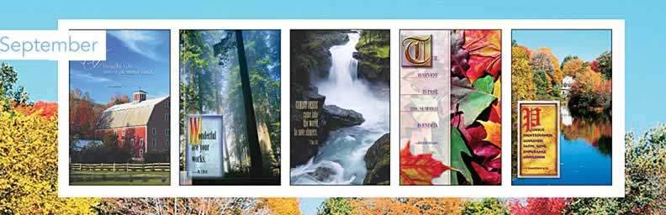

Sunday | 2 | 9 | 16 | 23 | 30
Liturgical Day | Fourteenth Sunday After Pentecost  (UM Kingdomtide) | Fifteenth Sunday After Pentecost  (UM Kingdomtide) | Sixteenth Sunday After Pentecost  (UM Kingdomtide) | Seventeenth Sunday After Pentecost  (UM Kingdomtide) | Eighteenth Sunday After Pentecost  (UM Kingdomtide)
Special Day | Labor Sunday | Grandparents’ Day |  | Christian Education Sunday
Lections Day | Jer. 2:4-13  Ps. 81:1, 10-16 or UMH 803  Heb. 13:1-8, 15-16  Luke 14:1, 7-14 | Jer. 18:1-11  Ps. 139:1-6, 13-18 or UMH 854  Philem. 1-21  Luke 14:25-33 | Jer. 4:11-12, 22-28  Ps. 14 or UMH 746  1 Tim. 1:12-17  Luke 15:1-10 | Jer. 8:18-9:1  Ps. 79:1-9 or Ps 4 or UMH 741  1 Tim. 2:1-7  Luke 16:1-13 | Jer.32:1-3a, 6-15  Ps. 91:1-6, 14-16 or UMH 810  1 Tim. 6:6-19  Luke 16:19-31
Suggested Colors | Green | Green | Green | Green | Green

Sunday | Monday | Tuesday | Wednesday | Thursday | Friday | Saturday
 |  |  |  |  |  | 1
2  Labor Sunday | 3  Labor Day | 4 | 5 | 6 | 7 | 8
9  Grandparents' Day | 10 | 11 | 12 | 13  Rosh Hashanah | 14 | 15
16 | 17  Citizenship Day | 18 | 19 | 20 | 21 | 22  Yom Kippur
23  Christian Education Sunday  Autumnal Equinox  First Day of Autumn | 24 | 25 | 26 | 27  Sukkot | 28 | 29
30

< Previous | Next >

